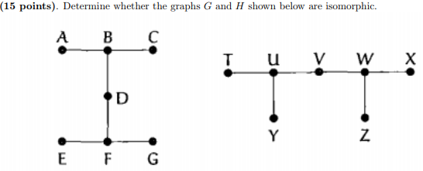

They are isomorphic because they have the same number of vertices and edges.
Now let’s see if the corresponding vertices have the same degree.
- deg(A) = deg(y) = 1, deg(B) = deg(u) = 3, deg(C) = deg(T) = 1,
deg(D) = 2 = deg(V), deg(E) = deg(X) = 1, deg(F) = deg(W) = 3,
deg(G) = deg(Z) = 1
Therefore, the corresponding degrees are equal to each other so it’s isomorphic.

We can also convert graph G into graph H by bending edges:
